HW1: (1倍分數)
請把附圖的 sample code 寫出來

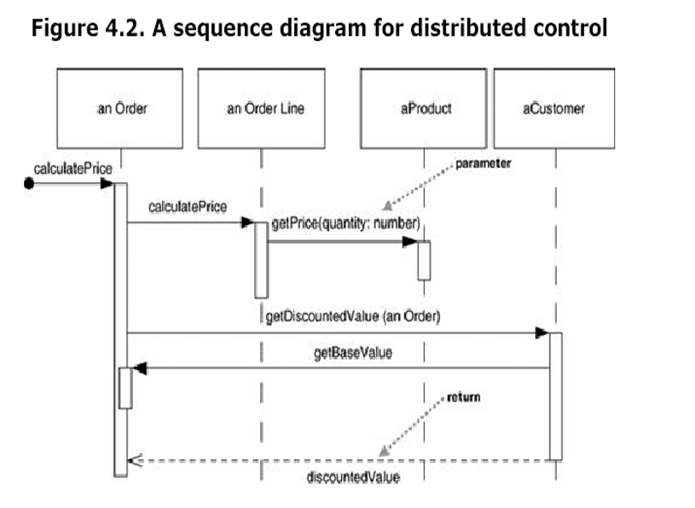

HW2: (1倍分數)
The following is a pseudo code for 104 Job-hunting website.
procedure searchjob
foreach (listedjob)
if (listjob.getSalary() > NT$50000)
high_level_customer.assign(listjob)
else
low_level_customer.assign(listjob)
end for
if (high_level_customer.getJobs() < 10)
high_level_customer.changeLevel(+1);
end procedure

Please draw the UML sequence diagram (diagram版本請至少是UML 2.0或以上)

HW3: (4倍分數)
請把附圖的 pseudo code 寫出來。
